**LoadRunner**

**How to Execute Vugen script using Command Prompt.**

To run a script from a command line or the Run dialog box:

1. Open a **Command Prompt** window, or select **Start** > **Run** to open the Run dialog box.
2. Type **mdrv** followed by the script name, using the following syntax:

<installation_dir>/bin/mdrv.exe -usr <script_name>

where **script_name** is the full path to the *.usr* script file, for example, **c:\temp\mytest\mytest.usr.**

1. Add other command line options and arguments.
2. Click **Enter**. The **mdrv** program runs a single instance of the script without the user interface. The output files provide the runtime information.

LoadRunner is a performance testing tool which works on different protocol

Web http/html, pop, web services, smtp, SAP, Remote Desktop Protocol, Web Services, java over http etc.

There are 3 components in LoadRunner

1. Vugen (Virtual User Generator)- use to write, edit and update the test script.
2. Controller (Performance Center)- LoadRunner agents is interface between host and controller
3. Analysis- Report generation and performance verification

**Vugen(Virtual User Generator)**

In Vugen we create the script, do the error handling of image, text using checkpoint, parameterization (for run the real time scenario where we are replacing hardcore value with real time behavior) and correlation for handling dynamic values in the script.

In Load Runner we have record the script for web application, we can select the recording option like HTML or URL based recording, we prefer to use HTML based recording.

1. Recording Option

1). General- Recording

Script

Protocol

Code Generation

2.) Correlation- Configuration, Rule

3.) Http Properties

4.) Network – Mapping and Filters- Socket Level and WinlNet Level

5.) Data format extensions Chain Configuration and Code Generation

Step:1

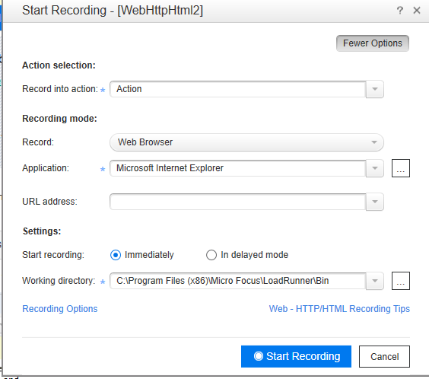

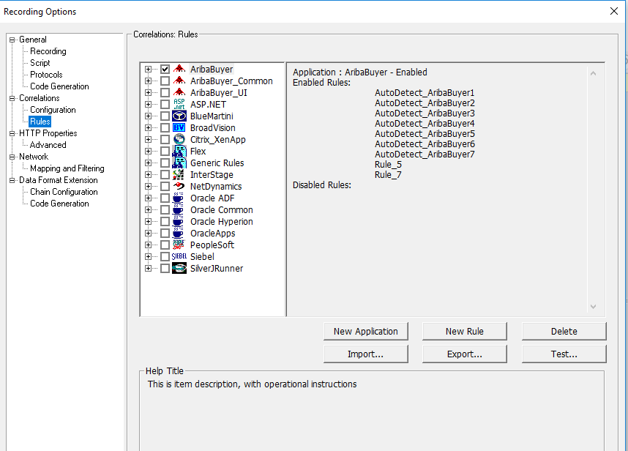

**Difference Between HTML Based Recording and URL Based Recording**

**HTML Based:**

It’s records scripting for every user action that is performed during recording, when we the HTML recording as you perform click and doesn’t give you inside information like what is happening behind the recording.

HTML mode records only required action and is more intuitive to read as statement are inside the functions.

HTML is recommended for browser applications.

Resource is 0

Function developed under this 1. Web_url, 2. Web_link, 3. Web_submit_link, 4. Web_submit_form.

HTML is default mode recording available in LoadRunner for web http/html scripts.

HTML script is easy to maintain, and less correlation is required

Ex: login into gmail, it will capture the login action with user id password and session id etc.

**URL Bases:**

URL based recording records each browser request to the server and resource received from the server.

URL based mode require more correlation

URL mode, all statements get recorded into web_url().

URL mode is recommended for non-browser application.

URL mode is developed based on the steps performed by the user

URL mode it will capture non-html base resources also like jpeg, bitmap etc.

Resource is 1

Functions for URL- web_url(), web_submit_data, web_concurrent_start, web_concurrent_end

Ex: login into gmail it will capture all browser actions like where request sent to the server, response from the server in .css file, jpeg etc

**Vuser Process vs Vuser Thread**

**Vuser Process:**

When Vuser run as a process the same driver program is loaded into memory for each user. This will take large amount of memory for each user and will limit the number of virtual user you run on a single generator.

Ex: if u run 10 vuser each user take some amount of memory, in that case each user required large amount of memory because of that no. of vuser need to decrease.

**Vuser Thread**

**W**hen Vuser run as thread, only one instance if driver program is shared by given number of vuser. You can run more vuser on a single generator, using multithreading mode.

**Runtime setting>Miscellaneous> Multithreading> Process/Thread**

**RunTime Settings**

**Run-logic**- No. of Iteration

**Pacing**-Define the delay between each iteration

**Log:** Standard log and expected log (We use only for debugging), extended log(Parameter Substitution, Data return by server, Advance tree)

**Think time:** delay between each action

**Miscellaneous**: Error Handling > continue on error, fail open transaction on lr_error_message

Multithreading> Thread and Process

Automatic Transaction: define each action as a transaction/ define each step as a transaction

**Browser**: Browser Simulation

**Network**: Speed Simulation and Streaming

**Internet protocol:** Content check, Proxy, Preference: Enable image and text checks(CheckPoint), Web Performance graph: hit per sec, page per sec, response byte per sec

**Http**

**Authentication**

**Logging**

**Javascript**

**Download filters**

**Log:**

**Standard logs:** Capture the log during execution, runs step by step.

**Advance Logs:** Store advance information like data return by server, advance trace parameter and much more information depending o the option we select in the run time settings. During execution controller automatically disable the LR logs.

**PARAMETERIZATION**

It is used for passing different values for each user or iteration. when you record an application in loadRunner it will hard code the values but in real time scenarios we want to use different values for execution.

1. Record script>Right click on the value which you want to parameterize

2.Give the parameter name> click on ok

3. it will ask you to replace all occurrence of the string with parameterize> click yes

4. Now Click on parameter as show in the select file and values

Type for parameter:

Date/Time, File, Group name, Iteration number, Load generator name, Random number, Table, unique Number, user define function, Vuser ID, XML

Three way of selecting parameterize in next row

1. Sequence

2. Random

3. Unique

Update vale on: each Occurrence , each iteration, once.

**Design> Parameter>**

**Correlation**

Correlation is used to handle the dynamic values in script. Dynamic values can we changed for each user action or for different value.

in both cases correlation take care of these values and prevents them from failing the script during execution.

Dynamic value is two type

1. Static: where Left boundary and right boundary is static

2. Dynamic: where LB and RB is also changed

**1. Manual correlation:**

1. Determine the value to capture

2. find the right and left boundaries of the value to capture

3. find which occurrence of the text boundaries should be used

4. Add a new step> goto the navigator>search> Web_reg_save_param_regexp> drag where you want to add> add parameter name>RegExp>LB and RB and occurrence of the function.

Web_reg_save_param_regexp("parameter="parameter name",

RegExp=entityid\":(.*?),\"Enityname\";\"(.*?)\"

search_filters

"scope_body".

"IgnoreRedirection=No;

"Group=0"

"Ordinal=all"

last);

**Auto Correlation:**

**Record the two script with similar steps and compare the scripts in HTML view or using wdiff and replay the recorded scripts and scan the for correlation.**

it work on pre-defined correlation rules. the script is played back and scanned for auto correlation on failing.

**Vugen identify the places wherever the correlation rule works and correlate the value**

Step:

1. Click on Record> Recording option>goto the correlation> configuration Rule

2. Mark as checked again all application

3. Click on new rules> action>=: All body text scan type_boundary base: lb and rb> select parameter prefix> prefix name

4. click on option

5. now replay the script

6. scan script for correlation

7. scan will do the comparison between actual and replay script

8. click on correlation

**Ordinal:**

It is used for real time scenarios creation, like I want to select different tabs, checkbox or dropdowns

Use Ordinal with Ordinal=All.

**Controller**

In performance center goto the test plan> create folder> upload the script>goto the test design> click on edit> set the scenarios.

Performance Center:

Test plan—create the scenario

Test Lab—store the scenarios

Test Run—Store the results

Test Resources—u can check the load generators

Controller, as the name suggests, is a program to “control” overall load test. It is responsible for helping you run your performance test design using the VUGen scripts you’ve already created. It lets you over-ride run-time settings, enable or disable think time, rendezvous points, adds load generators and controls the number of users each generator can simulate. It automatically creates a dump of execution results, gives you a live view of “current state” of load test running.

**Type of Controller:**

Manual Scenario:

It can be added % mode or number mode

Manual Scenario> LoadRunner Script>Click ok

Design Box:

Scenario Groups: Group name, Script path, Quantity, LoadGenerators

SLA agreement: TPS(Percentile, Average) , Error Per sec, Total hit, average per Sec, total Throughput, Average Throughput

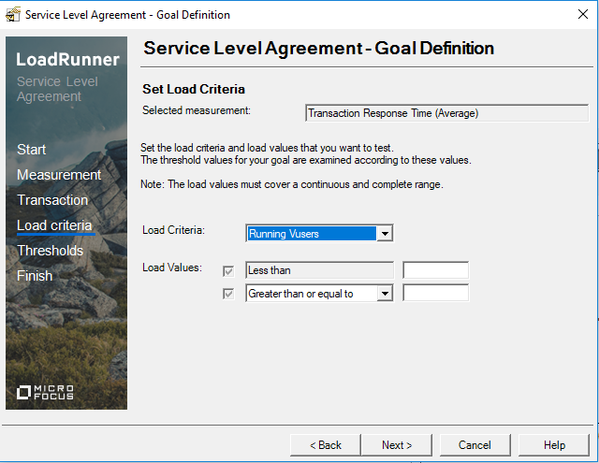

**Scenario Schedule**: Schedule name, Schedule by (Scenario, Group), Run Mode (Real World Scenario, basic Schedule)(We can add multiple scenarios)

Global Schedule: Initialize(Initialize all Vuser Simultaneously, Initialize no. of user per sec/min/hr, Initialize each vuser just before it runs) ( Start Vuser, Give Duration of Run, Rampup and Rampdown, stop in between)

Start Vuser: Start Vuser(Number of user), Simultaneously, No. of user every sec/min/hr

Duration: Run until completion, Run for no. of days and duration (HH:MM:SS)

Run: Graph can we added

Set the number of Iteration in controller. In Runtime Settings.

**Rendezvous Point:**

It is used for spike testing, it is instruct vuser to wait till all user come to a certain point and proceed together. The purpose of Rendezvous testing to verify the behavior of application responds with load or particular transaction.

Ex: 1000 customer try to deposit at same time. We will simulate to login 1000 vuser and do deposit at same time.

Put the Rendezvous point right before deposit transaction. Loadrunner pause the vusers who ever reach the point (login and see their account, about to deposit) and wait for all the user to reach to the particular point.

**How to add load Generator:**

First calculate the load generator require for run

To determine the required number of load generators:

1. Record a script using your specific protocol.
2. Replay a single Vuser in Controller and check the average CPU and the peak memory consumption of the mdrv.exe process by adding a counter for % Processor Time and Private Bytes.
3. Based on your load generator hardware and the CPU and memory consumption of a single Vuser, calculate the number of Vusers per machine.

[11. How the number of hits will grow, even if the maximum number of users is running in goal oriented scenario in loadrunner controller?](http://qualitytrainings.com/how_the_number_of_hits_will_grow%2C_even_if_the_maximum_number_of_users_is_running_in_goal_oriented_scenario_in_loadrunner)

There is a check box **Do not change recorded think time** in Edit scenario goal. If it is not checked, the controller will minimize the think time, and runs the load test. So, due to reduction in think time the frequency of the hits will increase.  
**Note:**If you select this option, you may need to increase the number of Vusers in your scenario in order to reach your target

[12. On what basis acceleration or deceleration of users will happen in goal oriented scenario in loadrunner controller?](http://qualitytrainings.com/on_what_basis_acceleration_or_deceleration_of_users_will_happen_in_goal_oriented_scenario_in_loadrunner_controller)

Goal oriented scenario scenarios will execute based on the goals defined. The main objective of the goal oriented scenario is to maintain the goal throughout the load test execution.

For example: You are running goal oriented scenario with the goal of 100 hits per second, with minimum number of users as 50 and maximum number of users as 150. If the actual hits per second is coming around 75, when the load test is running with 50 users, then the controller automatically increases the number of users based on the required hits. When the number of hits are above the goal, then the number of users will be decreased accordingly

[13. What are the options can be chosen if the load target is not reachable in loadrunner controller?](http://qualitytrainings.com/what_are_the_options_can_be_chosen_if_the_load_target_is_not_reachable_in_loadrunner_controller)

During the goal oriented scenario profile creation, you have to select the appropriate option for continuation or termination of load test, if the goal is not achievable.

There are two options available to choose for non-achievable goals:

**Stop scenario and save results.**Instructs the Controller to stop the scenario and save the scenario results, if the target you defined cannot be reached.

**Continue scenario without reaching goal.** Instructs the Controller to continue running the scenario, even if the target you defined cannot be reached.

If you want to get notified during the goal oriented scenario, if the goal is not reachable. Select the option  
**Receive notification.**Instructs the Controller to send you an error message indicating that the target cannot be reached.

[17. Where the load generator results will be stored during the load test execution in loadrunner?](http://qualitytrainings.com/where_the_load_generator_results_will_be_stored_during_the_load_test_execution_in_loadrunner)

If you have not mentioned the temporary folder for load generator, the results will be stored in the mentioned folder.  
Otherwise, the load generator is going to store the results in the temporary folder in the current user profile as:**C:\Documents and Settings\<user name>\Local Settings\Temp\**.

To see the actual folder, open the load generator details, and see the temporary folder to get the actual folder name with full path.

**Q40. How do you write user defined functions in LR?**  
Before we create the User Defined functions we need to create the external library (DLL) with the function. We add this library to VuGen bin directory. Once the library is added then we assign user defined function as a parameter. The function should have the following format: __declspec (dllexport) char* (char*, char*)

**Vugen And Scripting Questions:**

**How do you start the script?**  
  
We usually start the scripting after understanding of Business Critical Scenarios.  
  
**What are the various functions you have used while creating the scripts?**  
  
You should able to tell at least 10 loadrunner functions and different functions that you have used in different protocols.   
  
**What is Step download timeout error?**  
  
If the application does not respond in 120 seconds, step download timeout occurs in loadrunner. We can increase the step download timeout error in Loadrunner (Runtime Settings -> Preferences -> Options -> General -> Step Download Timeout.  
  
**What are the different type of parameters available?**  
  
Custom, Date/Time,File, Group Name, Iternation Number, Load Generator Name, Random Number, Table, Unique Number, User Defined Function and Vuser ID.  
  
**What is advanced trace?**  
  
It logs all the vuser messages and function calls.  
  
**What are the Logs available in LR?**  
  
Code Generation, Replay Log  
  
**What are the protocols you worked on?**  
  
Tell the protocols that you know and explain how good you are in that protocols.  
  
**Difference between Think Time & Pacing?**  
Think is time interval between two transactions.  
Pacing is the time interval between two iterations.  
**What is Parameterization & Correlation?**  
Parameterization is giving the input through a parameter file in loadrunner.  
Correlation capturing a required value from the server response in loadrunner. Example: SessionID.

**How do you run specific part of your script for a specified number of times?**  
  
We can run the specific part of the script by using blocks in run time settings -> General -> Run Logic.  
  
**What are different recording modes available in LR?**  
  
We have mainly two recording modes HTML mode and URL mode.  
  
**What are the advanced features of URL recording mode in LR 9.5?**  
We have mainly two features:  
Create concurrent groups for resources after their source HTML page.  
Use web_custom_request only.

**What is the difference between resource=0 and resource=1?**  
  
For example [www.msn.com](http://www.msn.com/) has many resources like images, JavaScript etc.  
Here [www.msn.com](http://www.msn.com/) Resource is 0 as it is the main URL and the corresponding resources like image resource is 1.  
  
**What is the difference between lr_abort and lr_exit?**  
  
**Lr_abort:** it stops the execution of the action part and executed the vuser_end section.  
**Lr_exit:** it exits from the particular action, script or iteration and there are different options with lr_exit;  
**Example:**  
lr_exit (LR_EXIT_VUSER, LR_FAIL);  
lr_exit (LR_EXIT_ACTION_AND_CONTINUE, LR_FAIL);  
  
**What is the difference between lr_eval_string and lr_save_string?**  
  
Lr_eval_string: It extracts a value from a given parameter.  
Lr_save_string: It saves c variable into loadrunner variable.  
  
**What is context less and context based?**  
  
Context less mean the request does not depend on the previous request. Context based means the request is dependent on the previous request.  
  
**What is the use of Save Count in web_reg_find?**  
  
Number of times the given text has found in a particular page.  
  
**What is Correlation and its function with attributes?**  
  
Capturing a value from the server response. The function name is web_reg_save_param. List of attributes are Step Name, ParameterName, LeftBoundary, RightBoundary, ORD, NotFound = Warning/Error, Savelen, Saveoffset.  
  
**How do you do auto correlation?**  
  
From Loadrunner 11.5 we have a beautiful option called Design Studio. The loadrunner will detect the dynamic values and we can do the correlation easily.  
  
**If source is not available, then how do you do correlation?**  
  
We have different option to do correlation, Generation Log, Replay Log.  
  
**Difference between “Save Offset” & “ Save Length” and what are test flags?**  
  
Save offset is used to ignore the number of letters and Save Length is used to save the length of the parameter.  
  
**When do you use Web_Custom_request?**  
  
The name of the function itself indicates the custom request. Web_custom_request is the last option that vugen prefer during creation of the script. It first tries to create the script using different web functions. This function is used by the vugen when it cannot interpret the requests with the other web functions.   
  
**Dynamically the post data is changing, what do you do?**  
  
In this situation, I will use web_custom_request and use the for loop to append the dynamically changing data to web_custom_request.  
  
**What are check point available in LR?**  
  
web_find, web_reg_find, web_image_check.  
  
**Do you write any user defined functions?**  
  
Make sure you prepare well for this question.  
  
**What are the run time settings you have used in your script?**  
  
We use the run time settings based on our requirements. Iteration, Run Logic, pacing thinktime etc.

**What is the difference between get and post request?  
Get Request Post Request**  
We can use up to 2048 character length. It has no restrictions  
Get request is less secure. Post request is secure.  
It can be cached It cannot be cached.  
It can be bookmarked It can not be bookmarked.  
  
**What is the difference between web_url and web_link?  
web_url:**  
It's a GET request  
The web_url function does not require a context  
web_url is recorded only when VuGen is in either URL–based recording or in HTML–based recording mode.  
**web_link:**  
web_link function is an action function that emulates a mouse click on the link that is defined by the attributes.  
The web_link function can be executed only in the context of a previous operation.  
web_link is recorded only when VuGen is in HTML-based recording mode.

**What is the difference between web_submit_data and web_submit_form?**  
  
**Web_submit_form Web_submit_data**  
It is a context based submission It is a context less submission  
It is recorded only html based It is recorded both in html and url mode.  
  
**What is the difference between web_submit_data and web_custom_request?**  
  
**Web_submit_data Web_custom_request**

It is a context less submission It is also context less submission.

We cannot write a custom request. We can write a custom request using this function.

We can send through get or post requestWe can send only post request  
  
**What is the difference between web_find and web_reg_find?**  
  
Web_find deprecated and we have only web_reg_find now.  
  
**What is the difference between lr_output_message and lr_error_message?**  
  
Lr_output_message

The **lr_output_message** sends message to the output window, log files (such as the Vaughan log file and the Application Management Web site and agent log file), and other test report summaries. When a script is run in VuGen, the output file is **output.txt.**  
  
Lr_error_message  
The **lr_error_message** function sends an error message to product output windows (such as the LoadRunner output window), log files (such as Vugen and the Application Management agent log file), and other test report summaries. For details regarding the output for each product, see the product's user guides.

If **Run-time settings > General > Miscellaneous > Fail open transactions on lr_error_message** is selected, calling **lr_error_message**will fail the transaction in addition to sending the message  
To send a message to the output file, you must enable logging in the run-time settings, and select **Always send messages**. If you select **Send messages only when an error occurs**, there is no output from this function.  
VuGen displays the message text of the **lr_error_message** function in the Execution log in red, using Error code 17999. Note that this function sends a message to the output even when logging is disabled in the run-time settings.

**Difference between Performance Center & Controller?**  
  
**HP Loadrunner HP Performance Center**  
It is a standalone application It is a web based application.  
Only single load test is executed at a time. Here we can execute multiple load tests.  
We cannot trace the requirements and defects Here we can trace the requirements and defects  
We cannot reserve time slots for machines Here we can use timeslots to reserve the machines  
Loadrunner is good if we are using from one location. Performance Center is good if we are operating from different locations.  
  
**How do you come to know which Vuser failed?**  
  
We can check in the vuser status message.  
  
**What is Rendezvous point?**  
  
When lr_rendezvous function is called, all the users wait at that point and executes the next step.  
  
**What is IP Spoofer in loadrunner?**  
  
We can create the IP addresses dynamically using IP Spoofer.  
  
**Can you configure load generators in Windows & Unix?**  
  
Yes, we can configure the load generators in both Windows and Unix.  
  
**Can we run different scripts by using Performance Center and the Controller?**  
  
Yes, we can run.

**Analysis**

**What are the default counters that loadrunner analysis file shows?**  
  
Vusers, Hits Per Second, Throughput, Average Transaction Response Time, Transactions per second.  
  
**What are the Operating Systems counters you monitor?**  
  
CPU, Memory, Disk, Network  
  
**Give me 5 server counters that you regularly check?**  
  
Response times, throughput, hits per second, CPU, Memory, Heap Memory.  
  
**What AWR Reports? From which version of the Oracle – AWR feature is added?**  
  
AWR stands for Automatic workload Repository. It is introduced from Oracle 10g.  
  
**What is Granularity?**  
  
Granularity is the time interval of sampling the data in loadrunner analysis.  
  
**Difference between Thread & Process?**  
  
**Thread Process**  
Threads are dependent on each other in a process Process are independent of each other  
Threads uses very less resources Process uses very high resources  
Threads shares the address space Process requires a separate address space  
Threads carry very less information when compared with process. Process carry more information  
  
**What is JVM & Unix?**  
  
JVM stands for Java Virtual Machine which is a platform independent and converts Java byte code to machine language. As it is platform independent we can execute the code on any operating systems.  
  
Unix is a multiuser operating system and has many flavors like Linux, Sun Solaris, AIX, HP Unix, Ubuntu etc.  
  
**What is Memory Leakage?**  
  
<http://en.wikipedia.org/wiki/Memory_leak>  
  
**What is Garbage Collection?**  
  
<http://en.wikipedia.org/wiki/Garbage_collection_(computer_science)>  
  
**What are the algorithms available in GC?**  
  
<http://stackoverflow.com/questions/15616919/java-available-garbage-collection-algorithms>

 there are 4 GC algorithms available in the Java Hotspot VM:

* The **Serial GC** - recommended for client-style applications that do not have low pause time requirements.
* The **Parallel GC** - use when the throughput matters.
* The **Mostly-Concurrent GC** (also known as Concurrent Mark-Sweep GC(CMS)) - use when the latency matters.
* The **Garbage First GC** (G1) - new GC algorithm, for CMS replacement.

**What is Heap memory?**  
<http://en.wikipedia.org/wiki/Heap_memory>  
  
**How do you monitor server counters?**  
  
We use Sitescope or NMON tool and different commands available in Linux VMSTAT, IOSTAT, TOP etc.  
  
**What is Table Scanning?**  
  
When there are no Proper indexes given in the database tables, some queries will scan the entire data in the tables and collect the results which will increase the response time.  
  
**What are context switches?**  
  
<http://en.wikipedia.org/wiki/Context_switch>  
  
**What is a deadlock?**  
  
Deadlock occurs when two or more processes/threads waiting for the other to finish and it never happens and this leads to deadlock. This situation will apply to hardware/software, Java and databases.  
  
**What do you suggest to your client if there is a sudden hike in the CPU utilization while execution?**  
  
Sudden hike in the CPU utilization might have many reasons. We need to analyze what caused the high CPU utilization by using different tools and profilers.  
  
**What is Parsing, Soft Parse, and Hard Parse?**  
  
**Parsing:** It will check the syntax, misspelled SQL keywords and authentication.  
  
**Soft Parse:** If the requested query is found in shared pool soft parsing occurs and it consumes less resources.  
  
**Hard Parse**: If the requested query is not found in shared pool hard parsing occurs and it consumes very high resources.  
  
**What is the difference between Web Server, Application Server and Database Server?**  
  
**Web Server**  
**Application Server**  
**Database Server**  
Ex: Apache, IIS and Nginx  
Weblogic and Websphere  
Oracle, My SQL, and SQL server  
It handles HTTP requests.  
It handles HTTP requests and it contains business logic.  
It handles different queries, and records.  
Resource utilization is low.  
Resource utilization is high.  
Resource utilization is high.  
  
**What is standard deviation in loadrunner?**  
  
Standard deviation in loadrunner is done with the total response times of a particular transaction.  
For example, if you ran a transaction for 10 iterations. It will take the 10 transaction response times and calculates the Standard Deviation. If the standard deviation between these 10 values is high. Then it is a bottleneck, it should always low.  
**Examples:**  
Response times for login page with 5 iterations ->1, 1, 1, 1, 1=Standard Deviation is 0  
Response times for a logout page with 5 iterations 1, 2, 3, 4, 5, 6=Standard Deviation is 2.5 which is high.  
  
**Is there any impact if we reduce “Think Time” up to 50%?**  
  
Yes, there will be impact as the load on the server increases if we decrease think time. Mainly we have an impact on response times, throughput and system resources etc.  
  
**How to check network bandwidth is not sufficient?**  
  
Data Transfer rate between application server and database server or between client and the server is more than the bandwidth, then we can conclude the bandwidth is not sufficient.  
  
**Weblogic Top Counters for Performance Testing:**  
  
Thread Pool, DB Connection Pool, Garbage Collection, Java Heap memory, Load Balancing, Application logs, Hard Page Faults.  
  
**Oracle DBA Top Counters for Performance Testing:**  
  
In AWR Report: Shared Pool Memory, Cache Hit Ratios, Top 5 Events, Top SQL by CPU, Top SQL by I/O, Top wait events, Buffer pool cache hit ratios.  
  
**Operating System Counters** are common for both Weblogic and Oracle DBA: CPU, Memory, Disk I/O, and Network.

**You have created several Auto Correlation rules. A new tester on your team is preparing to record a group of scripts on the same application on his workstation. What can you do to provide the tester with the correlation rules?**

I would  export the Auto Correlation rules to a .cor file, and then have the new team member import the .cor file into his Auto Correlation rules

### How many areas we can do the correlation?

Areas of correlation are:  
  
1) Iteam Data  
2)Time Stamp  
3)Links  
4)Check Boxes  
5)Radio Buttons  
6)List Buttons